Discrete Time Systems

X(n) really means x(nT), where T is the sampling interval. Digital frequency w is really wT = w/Fs= 2pifT. W goes from -pi to pi which is really -pi/Fs..p/Fs . pi is the max because it rotates half the circle on one sample and the the other half on the other sample. Up down up down. f =F/Fs which is in -1/2,1/2.

Discrete Time Convolution

For a discrete time system the general input/output relationship is

or in matrix form

where is the time-varying system matrix. For causal LTI systems the relationship simplifies to

which implements a finite impulse response filter with impulse response .

If the condition is met and is truncated to lengthand has length , then the impulse response matrix is tall with dimension and exhibits a band structure. The output has length . For example, if L=N=4 we have

Circular Convolution

If two sequences are N-periodic their convolution is

However, because h and x are periodic,

and therefore only N distinct output values are present in the output. Due to this periodicity we may express for as

Now suppose we wish to convolve two length N finite duration sequences and restrict the output to be unique only for. This corresponds to artificially imposing length N periodicity on the two sequences. Using modulo N arithmetic we may write the convolution as

where . To see that is indeed so restricted, note that

so takes on only N values. The matrix representation no longer exhibits the band structure. The impulse matrix is composed of right shifted permutations of its first row , the impulse response permutation vector. For N=4 this matrix has the form

Because has the form of a circulant matrix, is known as N-point circular convolution

Equivalency of Circular and Linear Convolution

What are the conditions under which performing circular convolution is identical to the standard linear convolution? All that is necessary to ensure that circular convolution produces the same output as linear convolutions is to transform the circulant matrix into a banded matrix of the form which is characteristic of casual LTI systems. To do this we appropriately zero pad the impulse response vector and the input vector. If has length and has length then by appending zeroes to and zeroes to we arrive at the desired banded structure. For our example L=N=4, the required quantities are

and the circulant matrix yielding an identical output to is

Linear Constant Coefficient Difference Equations

Useful in system modeling and filtering.

LCCDE Constitutes a Pth order linear constant coefficient autogregressive (AR) moving average (MA) difference equation. The AR is recursive in the sense that the outputs are delayed and then fed back in as in an IIR filter and hence are part of the output at time n. The MA is an averaging type filter wherein delayed weighted versions, i.e. superposition, of the input constitute the output as in an FIR filter.

LTI. Proof.

where we have assumed the coefficient of y[n] is unity, or equivalently, we have divided through by a0. Eqn says that the ouput at time n is the sum of P weighted past outputs Q-1 past inputs, and the present input. We shall assume all real coefficients.

Solution in Time Domain

Zero input response-zero initial values (intial conditions, i.e. at 0+, y[-p]=0,p=1…P ) on the delay shift register (no memory). natural response.

IC = 0, then get zero state response or forced response. Prefer forced response.

Total solution is summation of two.

In (), if x=0, then the zero input response also known as the or the homogenous or complentary solution will be y = sum().

Particular solution

As the effect of ICs dies down over time, i.e. becomes portions involving ICs go to zero, in the limit lim n->inf forced response will equal the particular solution.

impulse reponse is response to delta function with zero ICs.

Solution in z-Transform Domain

Generally, X a rational function N/Q,

Y = B/A N/Q

sum of poles

Digital Filtering

Here we discuss the impulse responses (IIR vs. FIR), input-output relationships, stability, and frequency response of casual LTI first and second order systems. Causality is necessary for the application of one sided Z-transform methods. We also mention briefly the general solution method to first and second order linear constant coefficient difference equations whose solution involves a steady state response and a transient response. We then generalize to higher order systems and present the conditions for stability in terms of pole locations. They toy examples presented here are useful in developing more complex filters that actually do something.

We emphasis first and second order systems because they are the building blocks of higher order systems and many times a second order system is sufficient to design a digital filter or model a physical system. Second order systems represent a good balance between number of parameters to capture the essential features of a system and mathematical tractability.

The analysis presented here is also the starting point for signal processing of random sequences which are a generalization of what is presented below. Gauss-Markov models are a direct generalization of the deterministic relationships discussed here.

Digital Filters

Let us denote H, G, Phi, and S as the transfer, magnitude, phase and spectrum functions for H.

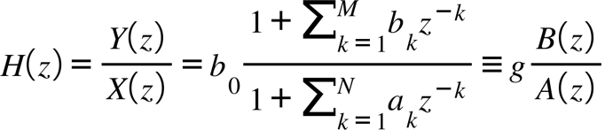

where without loss of generality we have divided the coefficients through by b0 and a0, renamed, and defined g as b0/a0 which we will often set to unity. Such linear systems are described by rational transfer functions.

By factorization theorem of algebra can be written as a ration of an Mth order numerator and Nth order polynomials with N poles pk and M zeros zk, respectively

$$H(z)=b_{0}\frac{z^{-M}\left(1+\sum_{k=1}^{M}{z^{M-k}}\right)}{z^{-N}\left(1+\sum_{k=1}^{N}{z^{N-k}}\right)}=b_{0}z^{N-M}\frac{\prod_{k=1}^{M}{(z-z_{k}})}{\prod_{k=1}^{N}{(z-p_{k}})}$$

By absorbing the M and N factors of z out front into the factored terms, () may also be written as

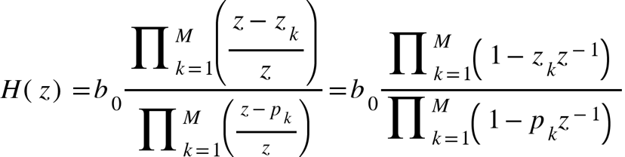

By evaluation () at 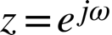 the frequency response is obtained. For complex zeros and poles, the FR is seen to be a product of vectors $P_{k}\left(ω\right)=e^{jω}-{ρ_{k}e}^{jθk}$ and $Q_{k}\left(ω\right)=e^{jω}-{rke}^{jϕ_{k}},$where 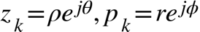. The magnitude and phase response, respectively, are, from ()

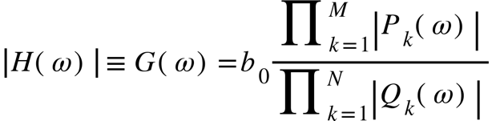

The power spectrum is

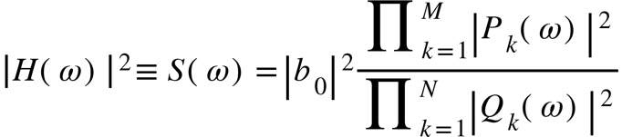

which can be written as

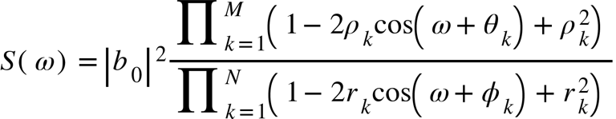

Note that for rational functions with real coefficients, complex valued poles and zeros occur in conjugate pairs, hence

.

The gain is chosen such that response at w1 is unity, ie.

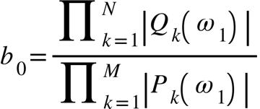

With regard to plotting transfer functions, we use the fact that for real coefficients h(n) is real, hence H(w) has conjugate symmetry which implies G is even and Phi is odd and without loss of generality we plot w from 0 to pi.

Group and Phase delay

Basic First IIR Order Filters

Simple filters derived from first order LCCDEs with real coefficient have real poles and zeros.

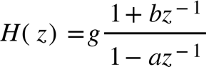
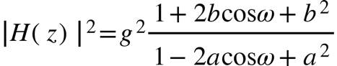

For a LPF, want H =1 at 0, and H=0 @ pi, hence g= and b=1.
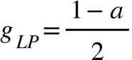

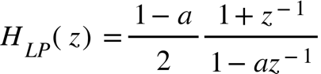
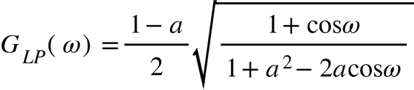
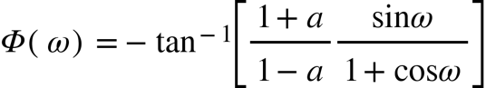

Has zero at z=-1, w=pi, and a pole at z=a. For HPF, want H=0 at 0 and H=1 at pi, hence g= and b=-1

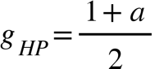

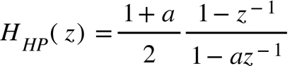
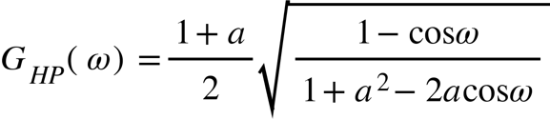
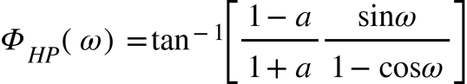
Has zero z=1, w=0, and a pole at z=a.

The 3db bandwidth for both is cos wc = 2a/(1+a^2)

Pole zero characterization

Response to Monochromatic Sinusoid

For LTI systems if the input is an eigenfunction of the form then the transfer function is the eigenvalue and the output is

For complex exponential inputs the output is

In other words the input sine wave is altered in amplitude and shifted in phase,

where and .

First order FIR system

Has impulse response

Z-t ransform

And frequency response

With magnitude

And phase
Where we have taken a0 unity because without loss of generality.

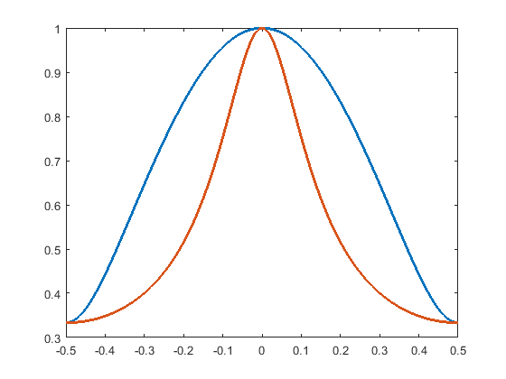
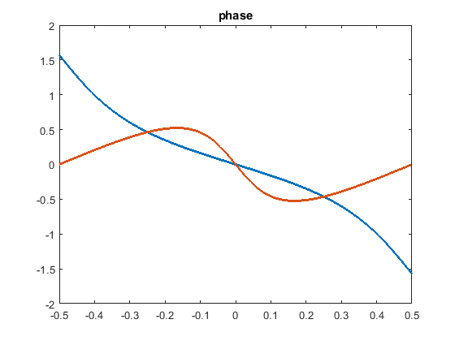
Comparison with first order IIR system.

First Order IIR Systems

First and second order systems are the building blocks of all higher order systems because by the fundamental theorem of algebra the poles of a rational function with real coefficients occur as simple poles or as complex conjugate pairs to a second order polynomial. If the constraint on real coefficients is relaxed the same result is true without the poles occurring as complex conjugates. In what follows the coefficients are not so restricted.

Consider the first order difference equation

where the input is , and y(-1) = 0.

Stability

The output is stable if . Using the convolution relationship for LTI systems we may determine the necessary condition for stability on the impulse response as follows:

where and the inner inequality follows from Cauchy-Schwartz. Thus, if the input is bounded for all time and the impulse response is absolutely integrable then the output is stable.

The impulse response may be found by substituting and working out the recursion

yields

Another method is to take the one sided z-transforms of both sides to find the transfer function and then inverse transform,

and picking off terms we see that . From the necessary condition for absolute integrability is , otherwise . From the necessary condition for the z-transform to converge is or . We see then that in the z-domain the condition for stability is that the ROC contain the unit circle which is a fundamental test for stability that we will revisit many times. Equivalently, the poles of the transfer function must reside inside the unit circle so that the leading ratioin is less than one.

Input-Output Relationship

The solution to is most easily arrived at via z-transforming both sides and then inverse transforming. We have

where which follows by the geometric series formula and converges for . To find y(n) we inverse transform by using either partial fraction expansion or by solving the contour integral . The advantage afforded by complex analysis is that it reduces the work load so let us demonstrate this by following such an approach. The inversion integral may be written as

which has two simple poles with residues Res(a) and Res(b). The residues are easily seen to be , respectively which then yield the output

For the input is the unit step function and the output is composed of a transient response term that decays over time and a steady-state response term. The parameter determines how quickly the transient response dies out. The closer a is to one the more gradual the decay. For a<1 the response exhibits an decaying oscillatory response.

Frequency Response

Due to the recursion implicit in the impulse response has infinite length and is therefore IIR type filter. By substituting , i.e. evaluating the z-transform on the unit circle in the z-plane or the imaginary line in the s-plane, we may deduce the frequency response magnitude

and phase

For the frequency response is a low pass filter and if the response translated by .5 and becomes a high pass filter. The maximum value of is . The parameter alpha governs the time and frequency response characteristics, i.e. first order systems are completely characterized by a single value. The parameter determines the narrowness of the frequency response. For the response is very peaked and exhibits good low pass performance, however this is at the expense of a longer transient response in the time domain. This is a classic time-frequency trade off.

We also note in passing that from the Figures the phase is approximately linear near DC. This is important in analog and digital receivers, tracking loops, modulators, etc.

Second Order FIR Systems

$$y(n)=b_{0}x(n)+x (n-1)+b_{2}x(n-2)$$

has impulse response of a three tap filter, $h(n)=\sum_{0}^{2}{δ(n-m)}$. The tranfser function is

H(z) = b0 + b1z-1 + b2z-2k

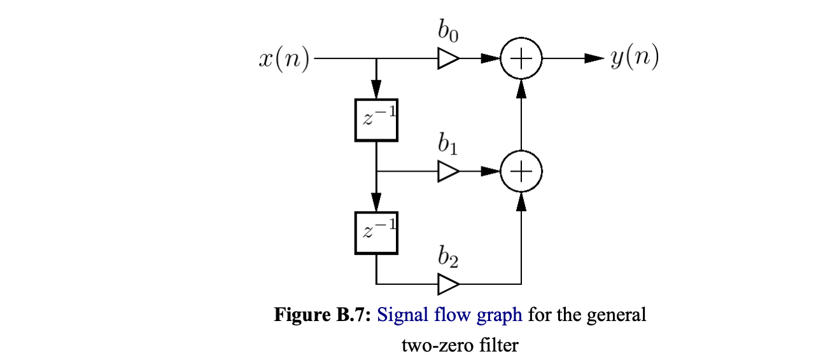

roots
z =

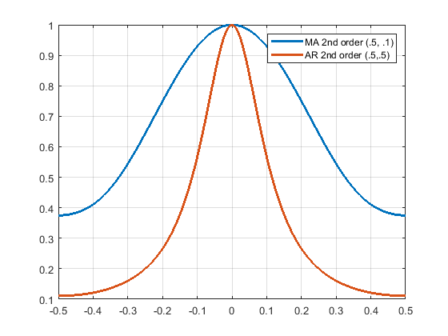

Second Order IIR Systems

Next we consider the system described by the autoregressive (AR) difference equation

where again ,y(-1)=y(-2)=0. Taking z-transforms of both sides yields the transfer function

The denominator in , known as the characteristic function, has roots

which will determine the physical operation of the system. We decompose the outcomes into three cases.

Critically Damped

For the characteristic function has two equal real roots which leads to

The impulse response is found by the inversion integral

which has a double pole with residue, hence the impulse response is

The condition will not ensure absolute integrability because grows linearly with . There must be the strict inequality so that the exponent dominates the linear term at infinity and ensures a bounded result at infinity. The output function in the z-domain is

whose corresponding time function is by residues

The results for various are plotted in figure () for input equal to the unit step function.

The frequency response is a doubly cascaded version of with transfer function

which has frequency response magnitude

and phase response

The graphical representation is similar to figure() with a steeper roll-off for the frequency response.

Underdamped

If the characteristic function exhibits two complex conjugate roots which we write for convenience as

Equating coefficients of like powers we obtain and . The transfer function is then

with frequency response magnitude

and phase

The frequency response has the form of a dual reasonator. The impulse response is obtained via the contour integral

which is easily computed by summing the conjugate residues to yield

Because we see that the condition for stability is or .

The frequency domain output adds the pole of the input and is

The output is readily computed via the contour integration procedure which led to and after some algebra is

Figure () is a plot of normalized with respect to the steady state value as a response to a unit step input.

From the figure we see that as decreases it attains its steady state value more quickly. The tradeoff is less ability to frequency shape.

Overdamped

For the denominator in has two distinct real roots or poles

The transfer function is

from which the impulse response is easily obtained

The condition for stability is , i.e. the poles must lie within or on the unit circle. The output is of the form

where the are easily determined constants.

Biquadratic Section

The biquadratic filter is a versatile filter that can assume essentially any second order IIR filter. The general second order case, known as a biquadratic section, can be written in terms of an FIR numerator and IIR denominator as

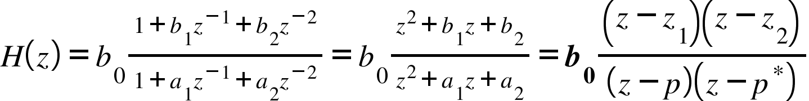

where , and we assume complex conjugate poles 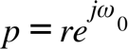 and real zeros, z1 and z2. In the following the gain b0 is set to unity, but we will establish its value in the sequel. Noting that the numerator and denominator have equal degree, we use the PFE

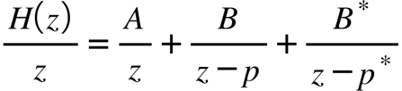

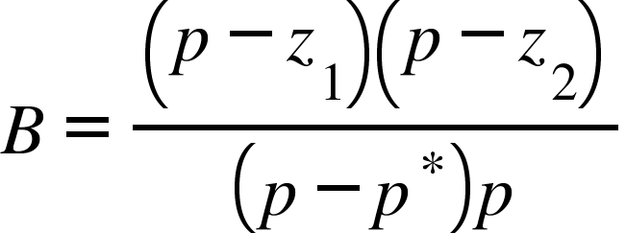

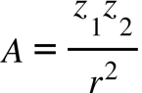

The inverse transform is accomplished by collecting terms of the form D+D and then using trigonmetric sum to product formula to arrive at

b0=1, w0=pi/4, r=0.9.

Note z1=z2=0, () reduces to a second order complex conjugate IIR system and for z1=0 and z2=rcosw0, reduces to an enveloped cosine function.

The frequency and phase responses are obtained from () by evaluating the magnitude (via law of cosines) and phase of the vectors

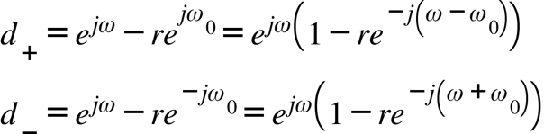

and using 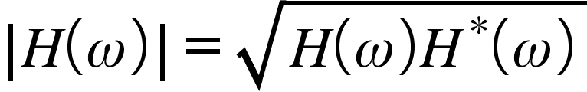

The magnitude response has the form of a digital reasonator, or equivalently a bandpass filter.

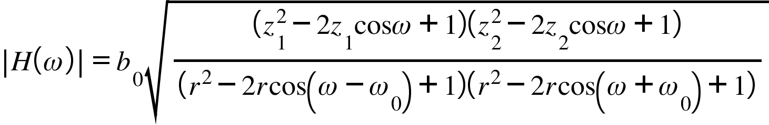
and the phase response is

When plotting take care to use atan2 and be mindful of phase unwrapping.

w = 0,pi, w0=pi/4

As a final activity, we investigate the selection of b0 to ensure unity gain at w0. Evaluating the amplitude response at the reasonant frequency and solving for b0 yields

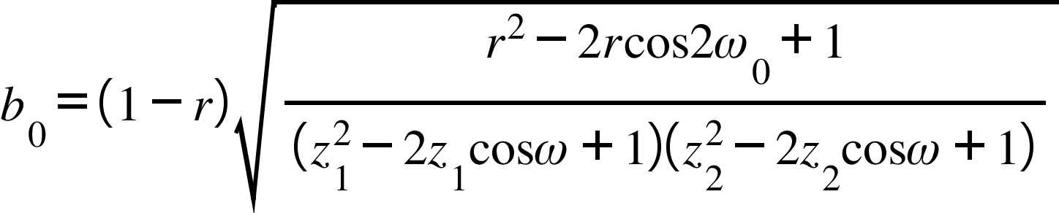

Notch filter

The previous exposition assumed real zeros. With complex zeros the filter generates a notch at w0. To make a notch filter set the FIR zeros to the same phase as the poles. The addition of poles drastically decreases the width of the notch for the same order. Such filters are also called bandstop.

A first order filter with complex zeros and poles can be constructed as the ratio of two vectors

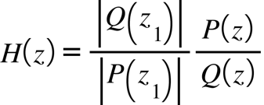

where z1 is the unity gain condition. For a notch filter setting z1=-1will ensure G(+/-1)=0, in which case () becomes

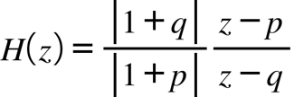

Using () and (), the magnitude and phase response are, respectively,

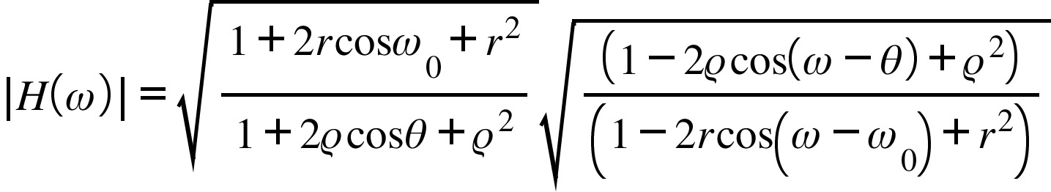

and

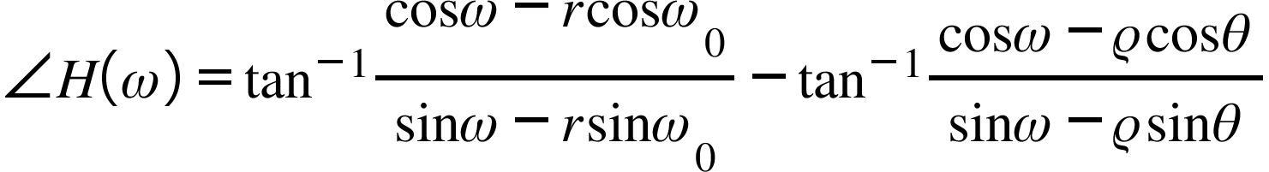
For general rho and theta exotic responses can be formed, however, for a notch filter theta = w0 and rho =1.

To calculate the bandwidth of the notch, we use the form of a dc null with w0=0 and calculate the cutoff frequency wc by solving ().

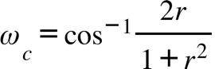

To determine r from wc, we can solve () for r by noting the right triangle formed with angle wc and hypotonus 1+r^2 and adjacent 2r, has opposite side r^2-1, from which we deduce
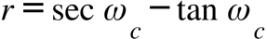

For a second order notch there are two symmetric nulls at +/- w0 corresponding to a cascade of two single vector conjugate polynomials with transfer function

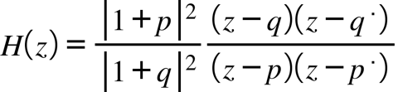

Using the vectors 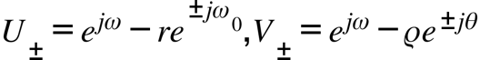 which are directed from a point on the unit circle to a pole or zero, it can be seen that as z approaches p and q (eg. w approaches w0), the magnitude of the vectors becomes arbitrarily small resulting in a steep null, whereas for all other positions it's large.

The magnitude and phase response are determined with similar recourse to the their inherent vectors:

where b0 was selected such that unity gain is achieved at w=pi. The phase response is

h = rho/r)^2 d(n) + (r.^n/sin(w0)).*(sin(w0*(n+1)) + (rho/r)^2*sin(w0*(n-1)) - 2*rho/r*sin(w0*n)*cos(theta));

Second order bandwidth is

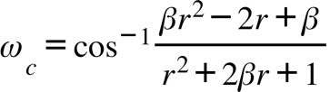

where 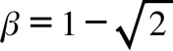.

Note the bandwidth on the second order is larger than first order due to the presence of the second null.

Bandpass and Bandstop filters

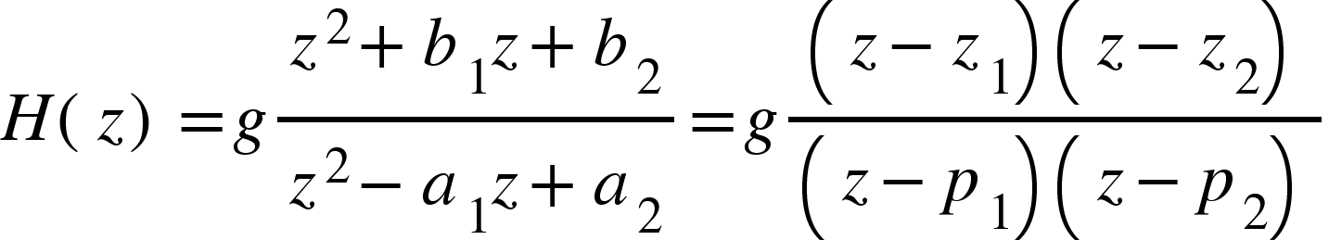
We need zeros at w=0,pi or z=1,-1 hence from the relationships
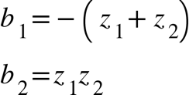
b1=1 and b2=-1. The squared magnitude is

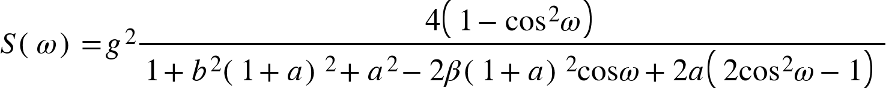

where we have defined the unity gain frequency 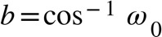 and bandwidth parameter , which are related to the poles by

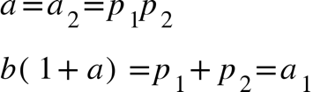

The condition 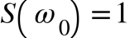, which after some algebra, reveals the gain to be 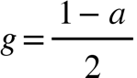
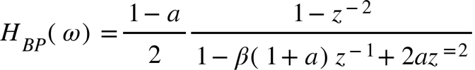

Linear Phase
Linear Phase

All Pass

All pass filters have constant frequency response and are used to modify the phase of input an input signal.

Given 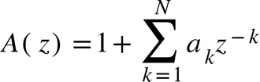 we want 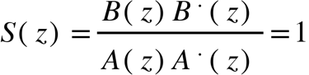, or constant response at all frequencies for some B. For real coefficients (see () ), if we choose , then with 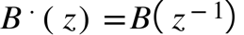, the magnitude is guaranteed to be unity. Therefore the implied relationship selects 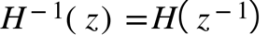. If we further define the reflected or mirror image polynomial
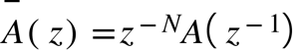
with reversed order of coefficients, then the all pass filter has the general form
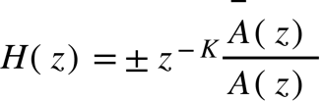
For simplicity, we set K=0 and select the positive sign. From () 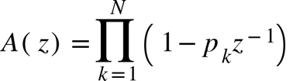, hence 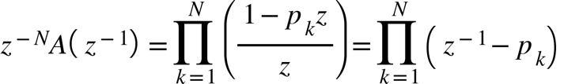we can write () in factored form as
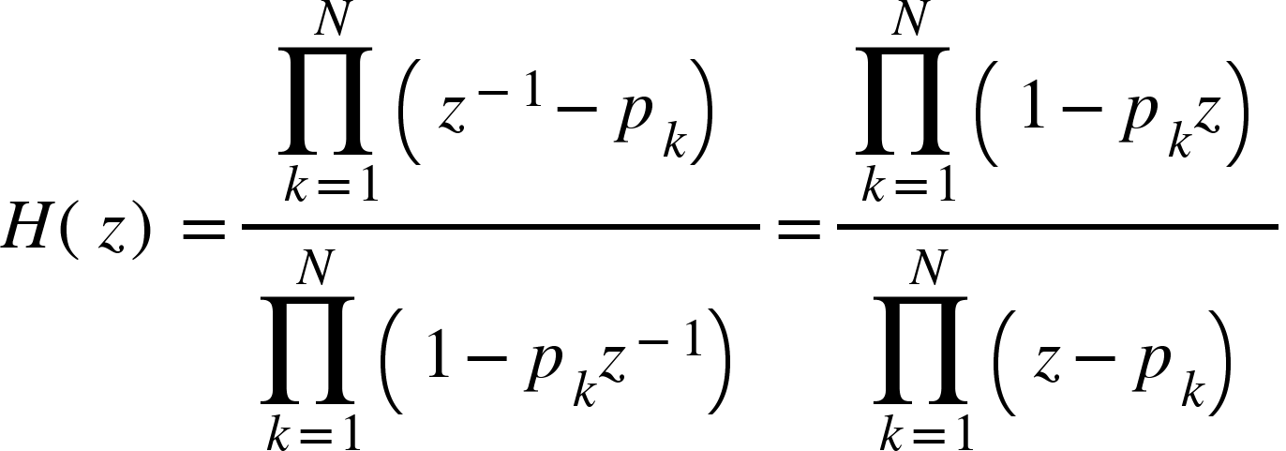

Thus for a pole , the corresponding zero is 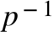. Eq can also be written in terms of Nr real rooted single order and (N-Nr)/2 complex conjugate pair rooted second order transfer functions

First order all pass filter with single complex pole

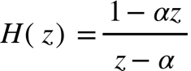
The phase response is the difference of the top and bottom

The phase is a non-positive curve where the pole magnitude controls the flatness of the curve, and the phase controls its maximum steepness.

Higher Order Systems

The general Nth order (N recursions on y) difference equation for a causal LTI system is

and has transfer function (note alpha 0 is equal to one)

where we assume to avoid improper rationals. If N=0 no recursion is present and the impulse response is of finite duration, it is a Finite Impulse Response (FIR). Otherwise the impulse response is of the Infinite Impulse Response type (IIR). It is a good exercise to compare the properties for similar ordered filters IIR and FIR filters.

If there are no repeated poles, then by the first fundamental theorem of algebra there are N possibly complex roots so that may be written as

where and are the M zeros and N distinct poles, respectively. The magnitude is Using residues or partial fraction expansion we find the impulse response is

where ’s are suitable constants. The condition for stability is then .

Now suppose there is an r^{th} () order pole at , then we may write as

where P is an Mth order polynomial and Q is an N-r order polynomial. The impulse response is then

The response due to the rth order pole is equal to the residue at ,

where . In the limit as becomes

and thus we see that that must be strictly less than one so that . The underlying difference then for simple poles and higher order poles is that stability is not achieved for poles on the unit circle.

